YEAR 11 GENERAL HUMAN BIOLOGY

DO NOT MARK THIS BOOKLET

Multiple Choice 15 Marks

Short Answer 15 Marks

Total 30 Marks

Task 2: Mitosis and Meiosis

Part 1: Multiple Choice (15 marks)

The following diagram refers to questions 1 and 2

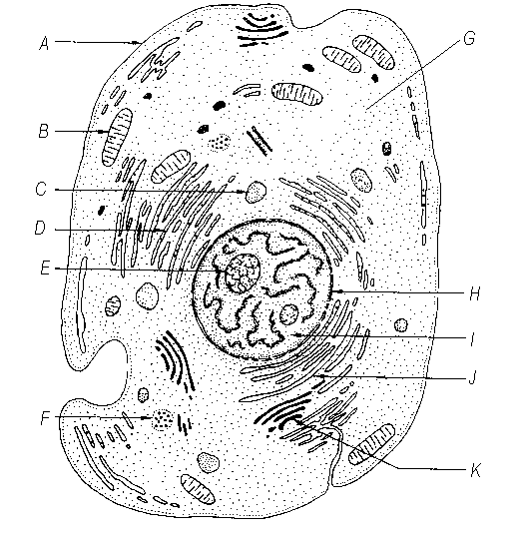

1. The part of the cell that is labelled E is the
2. nucleolus
3. nucleus
4. nuclear membrane
5. chromosome
6. The structure labelled D is responsible for
7. Cellular respiration
8. Protein synthesis
9. Removal of cellular waste
10. Diffusion
11. Which of the following structures are made out of DNA?
12. chromosomes
13. chloroplasts
14. cell membranes
15. mitochondria
16. How many different bases make up the “genetic alphabet” of DNA?

a) 2

b) 3

c) 4

d) 5

1. What shape is a DNA molecule?

a) X shaped

b) Double helix, like a twisted ladder

c) Star shaped

d) Arch shaped, like a rainbow

1. Which of the following statements is incorrect about chromosomes?
   1. Chromosomes are made of DNA.
   2. Chromosomes are found in the nucleus.
   3. Chromosomes contain genes for inheritance.
   4. Chromosomes are always visible under a microscope in stained cells.
2. Which of the following statements is incorrect about mitosis?
   1. It occurs in most body cells
   2. It produces cells with the same number of chromosomes as the original cell.
   3. It results in eggs or sperm.
   4. It occurs in growing or repairing tissues.
3. The diagrams below are microscopic photographs of a cell at various stages of mitosis.

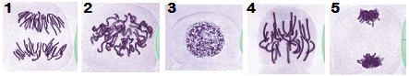

The correct sequence for these stages is

1. 1,2,3,4,5
2. 3,2,5,4,1
3. 3,2,4,1,5
4. 2,5,4,1,3
5. The process that produces eggs (ova), sperm and pollen is called
   1. mitosis.
   2. meiosis.
   3. cloning.
   4. fertilisation.

The diagram below shows a simplified model of a part of a DNA molecule.

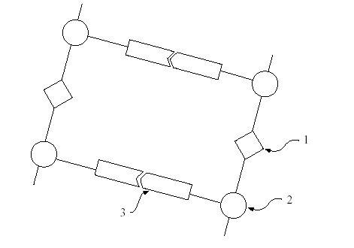

1. The parts labelled 1, 2, and 3 are respectively
2. nucleotide base, phosphate group, and sugar molecule.
3. nucleotide base, sugar molecule, and phosphate group.
4. phosphate group, nucleotide base, and sugar molecule.
5. phosphate group, sugar molecule, and nucleotide base.
6. Red blood cells are produced in the
7. Yellow bone marrow by meiosis
8. Red bone marrow by mitosis
9. Thymus gland by meiosis
10. Blood by mitosis

12 A student was studying a living cell under a microscope and observed chromosomes becoming visible. As the student continued to watch, the original cell divided into two daughter cells. Which of the following would the student have observed if this cell was undergoing mitosis?

(a) Each chromosome became attached at the centromere to a spindle fibre.

(b) Each chromosome paired up with another of similar size.

(c) Sections of chromosome being exchanged between pairs.

(d) The daughter cells had half the number of chromosomes of the original cell.

13 During the process of mitosis and meiosis there are a number of clearly visible stages. During which stage does replication of DNA occur?

1. Interphase G1 (b) Interphase S

(c) interphase G2 (d) Interphase P

14 . During cell division the DNA molecule replicates itself. The reason for this is so

1. if the cell makes a mistake there is enough DNA to go around
2. the daughter cells end up with the same genetic information as the parent cell
3. the DNA can move out of the nucleus into the cytoplasm
4. there are enough chromosomes for each cell produced.

The diagrams below represent the stages of a mitotic cell division.



15. Which letter sequence shows the correct order of the mitotic process?

(a) A,B,C,D,E,F

(b) B,F,E,D,C,A

(c) A,C,F,E,B,D

(d) F,E,D,C,B,A

**Section B Short Answer 15 Marks**

Question1

How many chromosomes are present in a cell in a human ovary during each of the following stages

A________ Prophase of the first meiotic division

B________ At the end of telophase of the first division

C________ Prophase of the second meiotic division

D________ at the end of telophase of the second division

1. marks)

Question 2

List and explain reasons for 4 differences between the processes of meiosis and mitosis.

1___________________________________________________________________________________________________________________________

____________________________________________________________________________________________________________________________

2_______________________________________________________________________________________________________________________________________________________________________________________________________________________________________________________3_______________________________________________________________________________________________________________________________________________________________________________________________________________________________________________________4_______________________________________________________________________________________________________________________________________________________________________________________________________________________________________________________ (8 marks)

Question 3

In the space below draw a diagram demonstrating the difference between a chromatid, chromosome and centromere. (3 marks)

**YEAR 11 GENERAL HUMAN BIOLOGY**

iti

G2HBY Task 2:

Mitosis and Meiosis

SCORES:

MC: /15

SA: /15

TOTAL: /30

_______ %

**NAME:_____________________________**

**TEACHER:__________________________**

**DATE:______________________________**

**Section A: Multiple choice (15 Marks)**

Answer all questions by circling the most correct answer on the multiple choice answer sheet.

1. a b c d 14. a b c d

2. a b c d 15. a b c d

3. a b c d

4. a b c d

5. a b c d

6. a b c d

7. a b c d

8. a b c d

9. a b c d

10. a b c d

11. a b c d

12. a b c d

13. a b c d